데이터베이스 명세

DB User ID : “PROJECT”

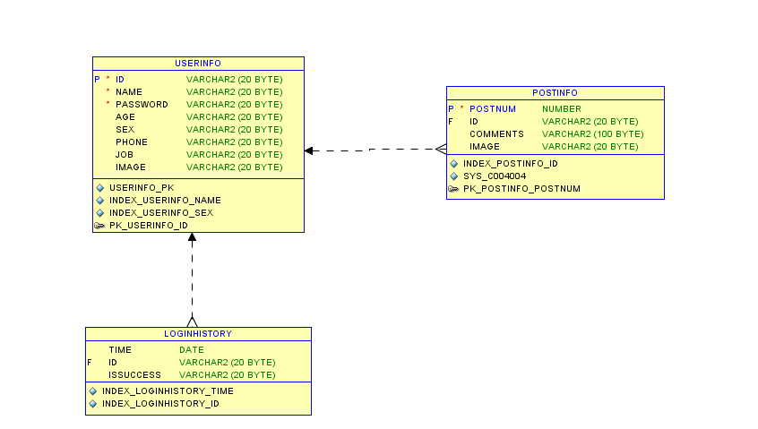

USERINFO : 가입된 사용자의 정보 테이블

|  |  |  |
| --- | --- | --- |
| Column ID | Column Name | Description |
| 1 | ID | 고유한 식별자 |
| 2 | NAME | 사용자 이름 |
| 3 | PASSWORD | 로그인시 사용되는 암호 |
| 4 | AGE | 사용자 나이 |
| 5 | SEX | 사용자 성별 (도메인: ‘MAN’ or ‘WOMEN’ |
| 6 | PHONE | 사용자 휴대폰 번호 |
| 7 | JOB | 사용자 직업 |
| 8 | IMAGE | 사용자를 담고 있는 그림 파일의 경로 |

SQL Query :

CREATE TABLE "PROJECT"."USERINFO"

(

"ID" VARCHAR2(20 BYTE) NOT NULL ENABLE,

"NAME" VARCHAR2(20 BYTE) NOT NULL ENABLE,

"PASSWORD" VARCHAR2(20 BYTE) NOT NULL ENABLE,

"AGE" VARCHAR2(20 BYTE),

"SEX" VARCHAR2(20 BYTE),

"PHONE" VARCHAR2(20 BYTE),

"JOB" VARCHAR2(20 BYTE),

"IMAGE" VARCHAR2(20 BYTE),

CONSTRAINT

"PK_USERINFO_ID" PRIMARY KEY ("ID")   
USING INDEX PCTFREE 10 INITRANS 2 MAXTRANS 255 COMPUTE STATISTICS STORAGE(INITIAL 65536 NEXT 1048576 MINEXTENTS 1 MAXEXTENTS 2147483645 PCTINCREASE 0 FREELISTS 1 FREELIST GROUPS 1 BUFFER_POOL DEFAULT) TABLESPACE "USERS" ENABLE

)

PCTFREE 10 PCTUSED 40 INITRANS 1 MAXTRANS 255 NOCOMPRESS LOGGING STORAGE

(

INITIAL 65536 NEXT 1048576 MINEXTENTS 1 MAXEXTENTS 2147483645 PCTINCREASE 0 FREELISTS 1 FREELIST GROUPS 1 BUFFER_POOL DEFAULT

)

TABLESPACE "USERS" ;

CREATE INDEX "PROJECT"."INDEX_USERINFO_NAME" ON "PROJECT"."USERINFO"

(

"NAME"

)

PCTFREE 10 INITRANS 2 MAXTRANS 255 COMPUTE STATISTICS STORAGE

(

INITIAL 65536 NEXT 1048576 MINEXTENTS 1 MAXEXTENTS 2147483645 PCTINCREASE 0 FREELISTS 1 FREELIST GROUPS 1 BUFFER_POOL DEFAULT

)

TABLESPACE "USERS" ;

CREATE INDEX "PROJECT"."INDEX_USERINFO_SEX" ON "PROJECT"."USERINFO"

(

"SEX"

)

PCTFREE 10 INITRANS 2 MAXTRANS 255 COMPUTE STATISTICS STORAGE

(

INITIAL 65536 NEXT 1048576 MINEXTENTS 1 MAXEXTENTS 2147483645 PCTINCREASE 0 FREELISTS 1 FREELIST GROUPS 1 BUFFER_POOL DEFAULT

)

TABLESPACE "USERS" ;

CREATE UNIQUE INDEX "PROJECT"."USERINFO_PK" ON "PROJECT"."USERINFO"

(

"ID"

)

PCTFREE 10 INITRANS 2 MAXTRANS 255 COMPUTE STATISTICS STORAGE

(

INITIAL 65536 NEXT 1048576 MINEXTENTS 1 MAXEXTENTS 2147483645 PCTINCREASE 0 FREELISTS 1 FREELIST GROUPS 1 BUFFER_POOL DEFAULT

)

TABLESPACE "USERS" ;

POSTINFO : 게시물의 정보 테이블

|  |  |  |
| --- | --- | --- |
| Column ID | Column Name | Description |
| 1 | POSTNUM | 고유한 식별자 |
| 2 | ID | 사용자 식별자 |
| 3 | COMMENT | 전달하는 내용 |
| 4 | IMAGE | 해당 Post에 대한 내용을 담고 있는 그림 파일의 경로 |
| 5 | LONGITUDE | 해당 Post를 올릴 당시의 경도 좌표 |
| 6 | LATITUDE | 해당 Post를 올릴 당시의 위도 좌표 |

SQL Query:

CREATE TABLE "PROJECT"."POSTINFO"

(

"POSTNUM" NUMBER,

"ID" VARCHAR2(30 BYTE),

"COMMENT" VARCHAR2(100 BYTE),

"IMAGE" VARCHAR2(100 BYTE),

"LONGITUDE" NUMBER,

"LATITUDE" NUMBER,

CONSTRAINT "PK_POSTINFO_POSTNUM" PRIMARY KEY ("POSTNUM") USING INDEX PCTFREE 10 INITRANS 2 MAXTRANS 255 COMPUTE STATISTICS STORAGE(INITIAL 65536 NEXT 1048576 MINEXTENTS 1 MAXEXTENTS 2147483645 PCTINCREASE 0 FREELISTS 1 FREELIST GROUPS 1 BUFFER_POOL DEFAULT) TABLESPACE "USERS" ENABLE,

CONSTRAINT "FK_POSTINFO_ID" FOREIGN KEY ("ID") REFERENCES "PROJECT"."USERINFO" ("ID") ENABLE

)

PCTFREE 10 PCTUSED 40 INITRANS 1 MAXTRANS 255 NOCOMPRESS LOGGING STORAGE

(

INITIAL 65536 NEXT 1048576 MINEXTENTS 1 MAXEXTENTS 2147483645 PCTINCREASE 0 FREELISTS 1 FREELIST GROUPS 1 BUFFER_POOL DEFAULT

)

TABLESPACE "USERS" ;

CREATE INDEX "PROJECT"."INDEX_POSTINFO_ID" ON "PROJECT"."POSTINFO"

(

"ID"

)

PCTFREE 10 INITRANS 2 MAXTRANS 255 COMPUTE STATISTICS STORAGE

(

INITIAL 65536 NEXT 1048576 MINEXTENTS 1 MAXEXTENTS 2147483645 PCTINCREASE 0 FREELISTS 1 FREELIST GROUPS 1 BUFFER_POOL DEFAULT

)

TABLESPACE "USERS" ;

CREATE UNIQUE INDEX "PROJECT"."SYS_C004004" ON "PROJECT"."POSTINFO"

(

"POSTNUM"

)

PCTFREE 10 INITRANS 2 MAXTRANS 255 COMPUTE STATISTICS STORAGE

(

INITIAL 65536 NEXT 1048576 MINEXTENTS 1 MAXEXTENTS 2147483645 PCTINCREASE 0 FREELISTS 1 FREELIST GROUPS 1 BUFFER_POOL DEFAULT

)

TABLESPACE "USERS" ;

LOGINHISTORY : 로그인 시도 기록 테이블

|  |  |  |
| --- | --- | --- |
| Column ID | Column Name | Description |
| 1 | TIME | 로그인을 시도한 시각 |
| 2 | ID | 사용자 식별자 |
| 3 | ISSUCCESS | 로그인 성공 여부 |

SQL Query :

CREATE TABLE "PROJECT"."LOGINHISTORY"

(

"TIME" DATE,

"ID" VARCHAR2(20 BYTE),

"ISSUCCESS" VARCHAR2(20 BYTE),

CONSTRAINT "FK_LOGINHISTORY_ID" FOREIGN KEY ("ID") REFERENCES "PROJECT"."USERINFO" ("ID") ENABLE

)

PCTFREE 10 PCTUSED 40 INITRANS 1 MAXTRANS 255 NOCOMPRESS LOGGING STORAGE

(

INITIAL 65536 NEXT 1048576 MINEXTENTS 1 MAXEXTENTS 2147483645 PCTINCREASE 0 FREELISTS 1 FREELIST GROUPS 1 BUFFER_POOL DEFAULT

)

TABLESPACE "USERS" ;

CREATE INDEX "PROJECT"."INDEX_LOGINHISTORY_ID" ON "PROJECT"."LOGINHISTORY"

(

"ID"

)

PCTFREE 10 INITRANS 2 MAXTRANS 255 COMPUTE STATISTICS STORAGE

(

INITIAL 65536 NEXT 1048576 MINEXTENTS 1 MAXEXTENTS 2147483645 PCTINCREASE 0 FREELISTS 1 FREELIST GROUPS 1 BUFFER_POOL DEFAULT

)

TABLESPACE "USERS" ;

CREATE INDEX "PROJECT"."INDEX_LOGINHISTORY_TIME" ON "PROJECT"."LOGINHISTORY"

(

"TIME"

)

PCTFREE 10 INITRANS 2 MAXTRANS 255 COMPUTE STATISTICS STORAGE

(

INITIAL 65536 NEXT 1048576 MINEXTENTS 1 MAXEXTENTS 2147483645 PCTINCREASE 0 FREELISTS 1 FREELIST GROUPS 1 BUFFER_POOL DEFAULT

)

TABLESPACE "USERS" ;

사용 Sequence

|  |  |
| --- | --- |
| Sequence ID | Description |
| POST_SEQ | POSTINFO 테이블의 POSTNUM 레코드 삽입을 위한 Squence |

CREATE SEQUENCE "PROJECT"."POST_SEQ" MINVALUE 1 MAXVALUE 100000 INCREMENT BY 1 START WITH 21 CACHE 20 NOORDER NOCYCLE ;